厦门迪太进出口有限公司
XIAMEN DITAI IMP.& EXP. CO.,LTD
地址：中国厦门禾祥西路鸿升大厦8A
8FL, Hongsheng Building, West Hexiang Road, Xiamen, Fujian, China
TEL:0592-26808108 FAX:0592-2680880 E-mail: irene.zhang@xmditai.com

Sodium Metabisulphite In Food CAS 7681-57-4

Classification:Sulphate
Type:Sodium Metabisulfite
CAS No.:7681-57-4 sodium metabisulphite
Other Names:sodium metabisulphite
MF:Na2S2O5
EINECS No.:231-673-0 Sodium Metabisulfite
Place of Origin:China (Mainland)
Purity:97%min
Appearance:White Powder Sodium Metabisulfite
Application:Dye printing mordant Sodium Metabisulfite, : Dye printing mordan
Brand Name:Xiamen DITAI
Model Number:PLS Sodium Metabisulfite
Color: Pure White

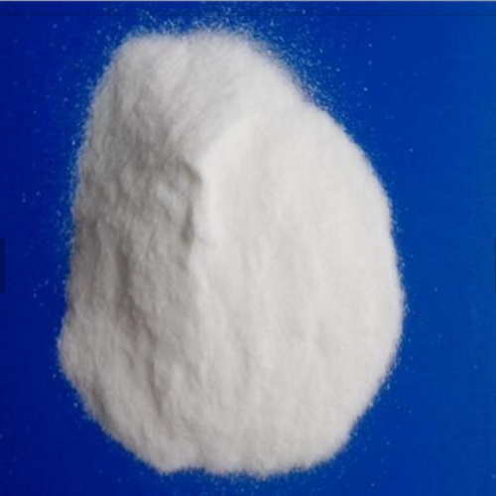

Sodium Metabisulfite Introduction: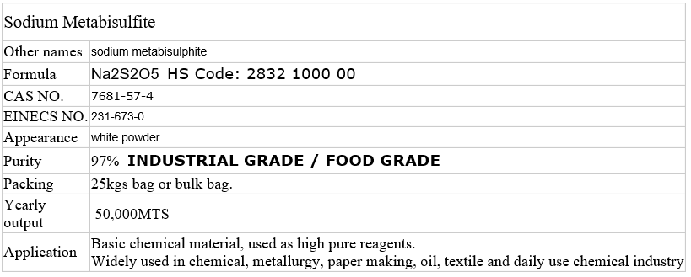

Sodium Metabisulfite COA:
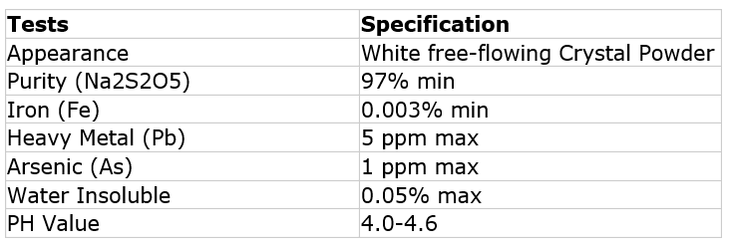
Sodium Metabisulfite Notice:
Store it in aeration and shady place . Not put it together with strong acids, oxidants. Avoid the
wrappage being perforated and prevent from water and moisture when conveyed. Exposure to moisture
will make it to be oxidized easily to release SO2. Do not store it for long time.
Sodium Metabisulfite Application:
Bleaching agent for textiles. Dechlorination agent for Bleached textiles. Bleaching agent
for paper pulps. Bactericide and antiseptic in food industries. Disposal agent for waste water,etc
​

